**INTI International College Penang School of Computing**

**3+0 Bachelor of Science (Hons) in Computer Science, in collaboration with Coventry University, UK 3+0 Bachelor of Science (Hons) in Computing, in collaboration with Coventry University, UK**

# Coursework cover sheet

**Section A - To be completed by the student.**

|  |  |
| --- | --- |
| Full Name: STEVEN TEO BOON JIE | |
| CU Student ID Number: P23014826 | |
| Semester: 2 | |
| Session:  **April 2023** | |
| Lecturer:  **Puteri Nursyawati Azzuri (puteri.azzuri@newinti.edu.my)** | |
| Module Code and Title:  **4067CEM Software Design** | |
| Assignment No. / Title:  **Continuous Assessment** | % of Module Mark:  **50** |
| Hand out Date:  **12 May 2023** | Due Date:  **Task 1: 02 June 2023, by 11.59pm.**  **Task 2: 07 July 2023, by 11.59pm**  **Task 3: 23 June 2023, by 11.59pm.**  **Task 4: 23 June 2023, by 11.59pm.**  **Task 5: 23 June 2023, by 11.59pm.** |
| Penalties: No late work will be accepted. If you are unable to submit coursework on time due  to extenuating circumstances, you may be eligible for an extension. Please consult the lecturer. | |
| Declaration: I/we the undersigned confirm that I/we have read and agree to abide by the University regulations on plagiarism and cheating and Faculty coursework policies and procedures. I/we confirm that this piece of work is my/our own. I/we consent to the appropriate storage of our work for plagiarism checking.  Signature(s): *STEVENTEO* | |

# Section B - To be completed by the module leader

|  |  |  |
| --- | --- | --- |
| Intended learning outcomes assessed by this work:   1. Understand and apply appropriate concepts, tools, and techniques to each stage of the software development. 2. Understand and apply design patterns to software components in developing new software. 3. Demonstrate an understanding of project planning and working to agreed deadlines, along with professional, interpersonal skills and effective communication required for software production.   5. Demonstrate an awareness of, and ability to apply, social, professional, legal, and ethical standards as documented in relevant laws and professional codes of conduct such as that of  the Malaysian National Computer Confederation. | | |
| Marking scheme | Max | Mark |
| 1. User Story Mapping | 20 |  |
| 2. Setting up a GitHub |  |
| Repository | 10 |
| 3. Creating a Class diagram and |  |
| design pattern selection | 30 |
| 4. Creating a Prototype User |  |
| Interface and Usability Testing | 20 |
| 5. Discuss the ethical issue |  |
| related to the software | 20 |
| Total | 100 |  |

**The 4067CEM assessment should be completed as a full individual work over the course of the module. The assessment output are only judged at the end of the module and not by the expectations during that week. The assessment should be undertaken individually. All submissions will be checked against each other and the internet for possible plagiarism.**

Activities – These activities consist of **50%** of your coursework marks. It will be run throughout the semester and there will be a final submission at the end of the semester. These activities consist of activities that will be done in a software design phase.

# System

Student Business System for College.

# Task 1 – User Story Mapping (20 marks)

The first thing that you need to do is ask the user what they wished for in a system. The user here can be your friends as the system is related to them. Get at least 10 real users to get their feedback. Document their feedback. Use software like Trello to complete this activity.

Output – All the user stories, and backlog with goals, activities, and tasks. In Word format, uploaded it to GitHub.

Due – Week 9 of the semester. 02 June 2023, by 11.59 pm.

# Task 2 – Setting up a GitHub Repository (10 marks)

This is where the output of the tasks will be stored, Make sure you register an account, create a repository and your files are uploaded here and it is in an organized manner and can be easily found.

Output – GitHub Repository with Task 1, Task 3, Task 4 and Task 5 documents. Take note the date of the files will be shown so you must follow the due date of each task.

Due – It will be accessed on Week 14 of the semester. 07 July 2023, by 11.59 pm

# Task 3 – Creating a Class diagram and design pattern selection (30 marks)

Create a simple Class diagram which should consists of the Classes that might be used to represent the system and the association between them. You don’t have to declare the attributes and operations for this activity. You do have to explain the class responsibility of each class declared. You can use software like StarUML to complete this activity.

Output – A class diagram containing classes and associations. In Word format, uploaded it to GitHub.

Consider the problem and select a suitable design pattern that can be implemented on the problem. Give justification on why the design pattern was chosen. Draw the UML diagram representing your class diagram as a design pattern UML. Include all the abstract class/interface, concrete class, and inheritance (if any) used to represent the problem.

Output – UML diagram representing the design pattern. In Word format, uploaded it to GitHub. Due – Week 12 of the semester. 23 June 2023, by 11.59 pm.

# Task 4 – Creating a Prototype User Interface and Usability Testing (20 marks)

Create a Prototype User Interface (hand drawn/digital) of TWO (2) important functions of the proposed system. Come up with usability testing questions. You don’t have to carry out the test, just prepare the questions. You should indicate what you are testing for in the Usability Testing.

Output – A Prototype and Usability Testing Questions. In Word format, uploaded it to GitHub. Due – Week 12 of the semester. 23 June 2023, by 11.59 pm.

# Task 5 – Discuss the ethical issue related to the software (20 marks)

Discuss and do a critical analysis of your software in these areas, privacy concerns, intellectual property rights, and effects on society.

Output – A report in Word format, uploaded to GitHub.

Due – Week 12 of the semester. 23 June 2023, by 11.59 pm.

# Submission

All tasks needed to be documented in Word format and submitted for SafeAssign checking (Links will be provided before the due date).

Upload the document and the SafeAssign report to your GitHub repository by each task due date. Due – It will be accessed on Week 14 of the semester. 07 July 2023, by 11.59 pm

# Marking Rubric for Continuous Assessment

|  |  |  |  |  |  |
| --- | --- | --- | --- | --- | --- |
|  | **Marks Below 40%** | **Marks in the range 40 – 49%** | **Marks in the range 50 – 59%** | **Marks in the range 60 – 69%** | **Marks 70% and above** |
| **User Story** | User Story Mapping | User Story Mapping | User Story Mapping | User Story Mapping | User Story Mapping done and does capture most important activities of the system. The breakdown of the user story mapping is excellent and uses software that can assist that process (For example Trello compared to Ms.  Word). |
| **Mapping** | not done or User | done at a minimum | done and does | done and does |
| **(20 marks)** | Story copied/does  not match the exact | level and does not  capture the | capture several  important activities of | capture several  important activities of |
|  | system. | important activities of | the system. The | the system. The |
|  |  | the system. | breakdown of the | breakdown of the user |
|  |  |  | user story mapping | story mapping is good |
|  |  |  | can be improved. | and uses software that |
|  |  |  |  | can assist that |
|  |  |  |  | process (For example |
|  |  |  |  | Trello compared to |
|  |  |  |  | Ms. Word). |
| **Setting up a** | GitHub repository | GitHub repository | GitHub repository | GitHub repository exist | GitHub repository |
| **GitHub** | does not exist or | exist and some of | exist and most of the | and all of the required | exist and all of the |
| **Repository** | cannot be accessed | the required files are | required files are | files are available at | required files are |
| **(10 marks)** | or the required files  are not available at | not available at the  time of access. | available at the time  of access. However | the time of access.  However the dates for | available at the time  of access. The dates |
|  | the time of access. |  | the dates does not | some files does not | on the files follows |
|  |  |  | follow the required | follow the required | the required |
|  |  |  | deadline. | deadline. | deadline. |
| **Creating a** | The Class diagram | The Class diagram | The Class diagram | The Class diagram | The Class diagram |
| **Class diagram** | does not represent | and design pattern | and design pattern | and design pattern | and design pattern |
| **and design pattern selection (30 marks)** | the required solution (contains generic or non- related classes  such as admin), the design pattern | represent the required solution but in a very general and incomplete way.  Required classes in | represent the required solution in a partial way. A few  required classes in the design are not | represent the required solution in a satisfactory way. Most  required classes are declared. | represent the required solution in an excellent way. All  required classes are declared. |
|  | suggested is not | the design are not | declared. |  |  |
|  | suitable for the given | declared. |  |  |  |
|  | problem. |  |  |  |  |

|  |  |  |  |  |  |
| --- | --- | --- | --- | --- | --- |
| **Creating a Prototype User Interface and Usability Testing**  **(20 marks)** | No prototype were available or the measurement for the usability testing is not clear. | The prototype cover minimalist and trivial design (such as login) and the measurements for the usability testing are not clear. | The prototype cover adequate design and several measurements for the usability testing are not clear. | The prototype cover good design and most measurements for the usability testing are clear. | The prototype cover excellent design and all measurements for the usability testing are clear. |
| **Discuss the ethical issue related to the software**  **(20 marks)** | There is no discussion on the ethical issue or only the theories are pasted back for this component. | There is an attempt to discuss on the ethical issue but no critical  analysis was done | There is an attempt to discuss on the ethical issue with some critical analysis was done | There is an attempt to discuss on the ethical issue with good critical analysis. | There is an attempt to discuss on the ethical issue with excellent critical analysis. |

**Task 1: User Story Mapping**

First, the user should be asked about their system preferences. In this case, friends and people around is choosed as the users related to the system. Feedback from at least 10 real users have be obtained and documented. Software such as Trello is utilized to accomplish this task.

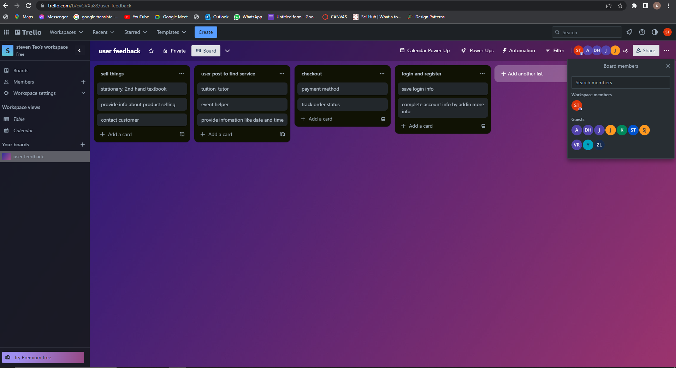

User Story Mapping: Student Business System for College.



Introduction:

At the outset, students are required to register an account to gain access to the Student Business for College system. Existing users can log in directly, while new users can provide additional information such as their birthday, favorite products, and interested categories to complete their account profile.

User Roles and Features:

Once registered, users can seamlessly switch between the roles of seller and customer without the need for a separate account. As a seller, users can easily manage their business by adding, deleting, and editing product information within the "My Shop" section. Additionally, users can offer services such as tutoring or event assistance. In the event that a product is sold out, users have the option to either permanently delete the product information or retain it for future reference. Furthermore, users can maintain communication with customers who have purchased their items to address any potential issues.

For customers looking to purchase products, the system provides several convenient features. Users can search for specific products using keywords, browse through different categories, and utilize advanced search filters such as price, rating, and payment options. Detailed product descriptions and previews are available to help customers make informed decisions. Once a desired item is identified, customers can add it to their basket and choose to proceed with immediate checkout or save it for later. During the payment process, customers have the ability to select their preferred payment method, apply discount promo codes, and even use coupons. Furthermore, users can track the status of their previous orders and receive information regarding estimated delivery dates. In the event of any changes or inquiries, customers can directly contact the seller through provided contact numbers or online chat support. Upon receiving the product or completing the service, customers can rate their experience through comments, image uploads, and rating stars.

Finding Services:

In addition to buying and selling products, users of the system can also post requests to find services. Whether it's looking for a tutor, an event helper, or any other service, users can create posts specifying their requirements. This allows other users who offer the desired services to respond and engage in potential business opportunities. The system facilitates seamless communication between service seekers and providers, ensuring efficient coordination and satisfaction.

Customer Support:

Lastly, the system offers comprehensive customer support. Users can contact the support team through a dedicated phone number to address any queries or submit complaints, ensuring a seamless user experience.

Conclusion:

The Student Business for College system simplifies the process of buying and selling for students. With its user-friendly interface and versatile features, students can effortlessly engage in commerce, conveniently manage their businesses, find services, and enjoy efficient customer support.